St. John Neumann Regional School SEPTEMBER 2017 LUNCHES

Student___________________________________ Grade ______ Print & return with payment $___________ Cash/Check ___________

SUNDAY | MONDAY | TUESDAY | WEDNESDAY | THURSDAY | FRIDAY | SATURDAY
 | AUG 28  Early Lunch/early dismissal  Packed Lunch | 29  & Drink only this week | 30 | 31 | SEP 1  NO SCHOOL | 2
3 | 4  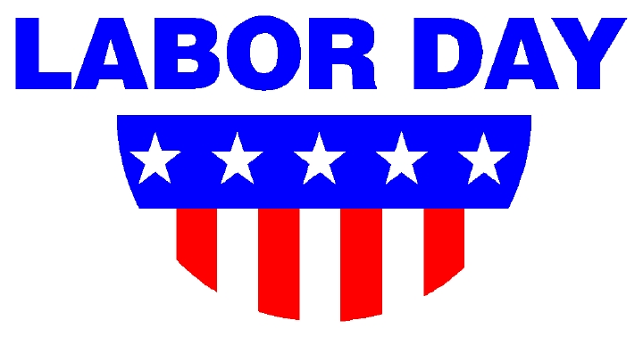 | 5  Salisbury Steak  Mashed Potatoes  Milk Only | 6  Smoked Sausage  Parsley Potatoes  Milk Only | 7  Turkey Wrap  Macaroni Salad  Milk Only | 8  Pizza  Dessert  Milk Only | 9
10 | 11  Subway Mondays*  T H I  Milk Only | 12  Hot Dog  Baked Beans  Milk Only | 13  Pancakes  Sausage  Milk Only | 14 Circle One:  Hamburger/  Cheeseburger  Hash Browns  Milk Only | 15  Pizza  Dessert  Milk Only | 16
17 | 18  Subway Mondays*  T H I  Milk Only | 19  Fish Sticks  Tater Tots  Milk Only | 20  Breaded Chicken Sandwich  Corn  Milk Only  NO LUNCH | 21  Meatball Sub  Green Beans  Milk Only | 22  Pizza  Dessert  Milk Only | 23
24 | 25  Subway Mondays*  T H I  Milk Only | 26  Chicken-Bacon-Ranch Casserole  Salad  Milk Only | 27  Grilled Cheese  Spaghettios  Milk Only | 28  Taco Rice  Mexican Corn  Milk Only | 29  Pizza  Dessert  Milk Only | 30
Lunches (includes drink): $3.75 each +$2.25 additional entrée/.55 Milk Only
*SUBWAY Selections: T = Turkey, H = Ham, I = Italian

