St. John Neumann Regional School SEPTEMBER 2018 LUNCHES

Student___________________________________ Grade ______ Print & return with payment $___________ Cash/Check ___________

SUNDAY | MONDAY | TUESDAY | WEDNESDAY | THURSDAY | FRIDAY | SATURDAY
 | AUG 27  Early Lunch/early dismissal  Packed Lunch | 28  & Drink only this week | 29 | 30 | 31  NO SCHOOL | 1
2 | 3  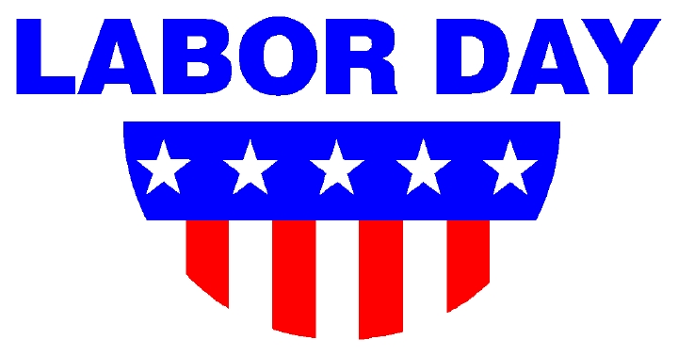 | 4  Hamburger BBQ  Dipping Veggies  Milk Only | 5  Chicken Nuggets  Mashed Potatoes  Milk Only | 6  Choc. Chip Waffles  Sausage  Milk Only | 7  Pizza  Dessert  Milk Only | 8
9 | 10  Subway Mondays*  T H I  Milk Only | 11  Chicken & Waffles  Mixed Vegetables  Milk Only | 12  Grilled Cheese  Oodles of Noodles  Milk Only | 13  Meatball Hoagie  Green Beans  Milk Only | 14  Pizza  Dessert  Milk Only | 15
16 | 17  Subway Mondays*  T H I  Milk Only | 18  Pancakes  Bacon  Milk Only | 19  Spaghetti/Meat Sauce  Salad  Milk Only  NO LUNCH | 20  Breaded Chicken Sandwich  Corn  Milk Only | 21  Pizza  Dessert  Milk Only | 22
23 | 24  Subway Mondays*  T H I  Milk Only | 25  Turkey Wrap  Chips  Milk Only | 26  Hot Dog  Baked Beans  Milk Only | 27  Breakfast Bowl  Fruit  Milk Only | 28  Pizza  Dessert  Milk Only | 29
Lunches (includes drink): $3.75 each +$2.25 additional entrée/.55 Milk Only
*SUBWAY Selections: T = Turkey, H = Ham, I = Italian

