October 2018 LUNCHES St. John Neumann Regional School

Student______________________________Grade ____Print & return with payment Cash $_______Check # _____Check Amt.$_____
SUNDAY | MONDAY | TUESDAY | WEDNESDAY | THURSDAY | FRIDAY | SATURDAY
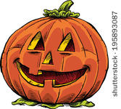 | 1  Subway Mondays*  T H I  Milk Only | 2  Chili, Nachos with cheese  Milk Only | 3  Chicken Bar-B-Q  Corn  Milk Only | 4  Macaroni and cheese  Carrot sticks  Milk Only | 5  Pizza  Dessert  Milk Only | 6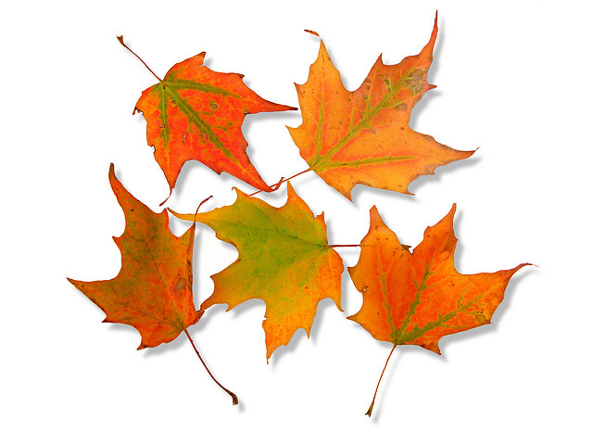
7 | 8  Subway Mondays*  T H I  Milk Only | 9  Ham and Cheese Mini Club  Chips  Milk Only | 10  Salisbury steak with mashed potatoes  Milk Only | 11  Blueberry Pancakes,  Sausage  Milk Only | 12  Pizza  Dessert  Milk Only | 13
14 | 15  Subway Mondays*  T H I  Milk Only | 16  Hamburger with or  without cheese  Carrots  Milk Only | 17  Lasagna  Salad and Roll  Milk Only | 18  Beef and broccoli over rice  Roll  Milk Only | 19  Pizza  Dessert  Milk Only | 20
21 | 22  Subway Mondays*  T H I  Milk Only | 23  Egg, cheese, and ham on English muffin  Hash Browns  Milk Only | 24  Chicken Parm Sandwich  Green Beans  Milk Only | 25  Hot dog with or without cheese  Tater Tots  Milk Only | 26 FREE LUNCH,  WALKATHON  Pizza  Dessert  Milk Only | 27
28 | 29  Subway Mondays*  T H I  Milk Only | 30  Smoked Sausage, Parsley Potatoes  Milk Only  Lunches (includes drink) $3.75 each + $2.25 add’l entrée/.55 Milk Only | 31  Popcorn Chicken Bowl, Roll, Brownie  Milk Only | Nov 1  Grilled Ham Sandwich with or without cheese  Cheese Curls  Milk Only | 2  Pizza  Dessert  Milk Only | 3
*SUBWAY Selections: T = Turkey, H = Ham, I = Italian

