December 2018 St. John Neumann Regional School LUNCHES

Student _____________________Grade ____Print & return with payment Cash $_______Check # _____Check Amt.$_____
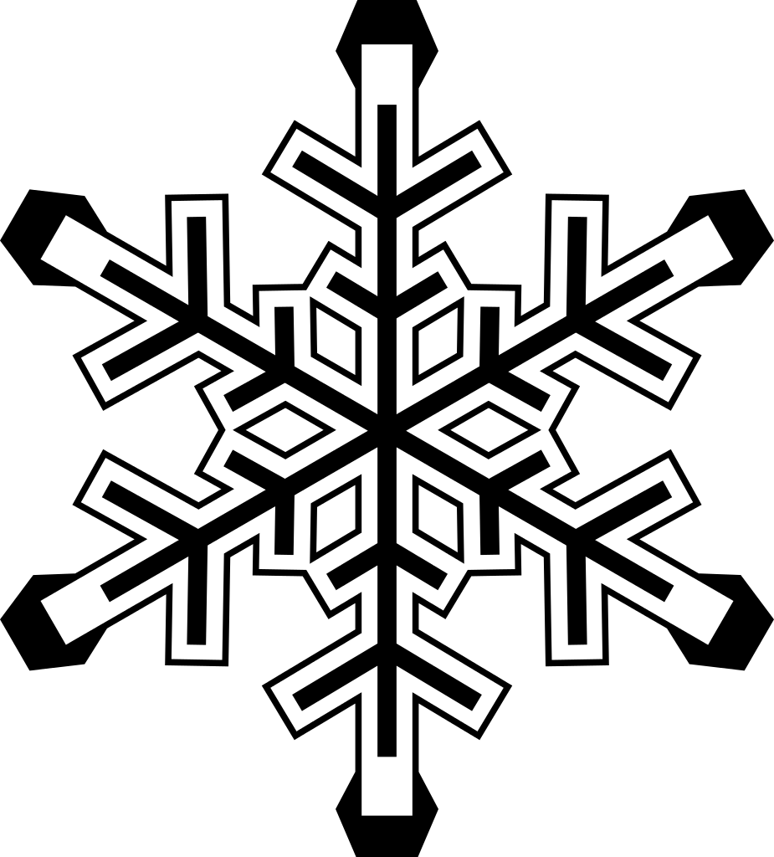
SUNDAY | MONDAY | TUESDAY | WEDNESDAY | THURSDAY | FRIDAY | SATURDAY
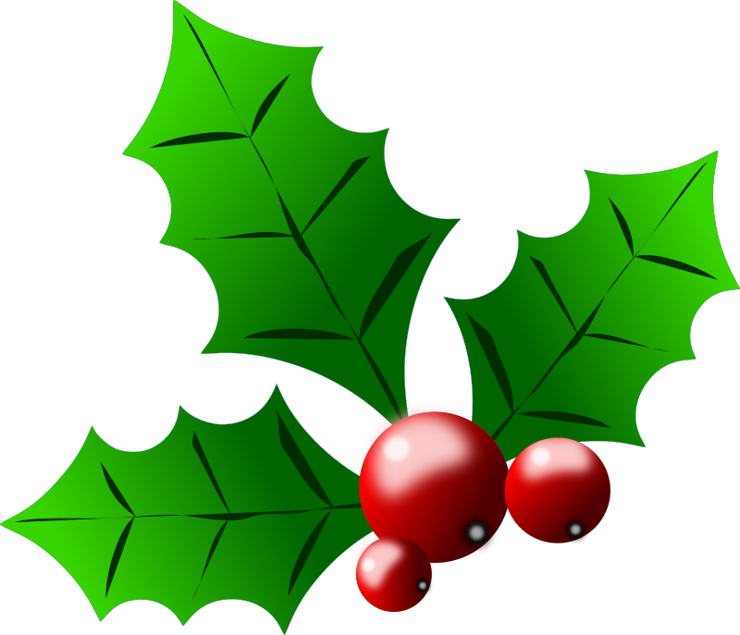 |  |  |  |  |  | 1
2 | 3  Subway Mondays*  T H I  Milk Only | 4  Baked Ziti, Fresh  Vegetables, Roll  Milk Only | 5  Fish Sandwich,  French Fries  Milk Only | 6  Pancakes,  Sausage  Milk Only | 7  Pizza  Dessert  Milk Only | 8
9 | 10  Subway Mondays*  T H I  Milk Only | 11  Chicken Cordon  Bleu, Corn  Milk Only | Early Lunch  12  Homemade  vegetable soup,  Grilled Cheese  Milk Only | 13  French Toast,  Ham  Milk Only | 14  Pizza  Dessert  Milk Only | 15
16 | 17  Subway Mondays*  T H I  Milk Only | 18  Meatball Sandwich,  Pierogies  Milk Only | 19  Macaroni &Cheese  with Hot Dogs  Carrots  Milk Only | 20  Open face hot Roast Beef Sandwich, Mashed Potatoes  Milk Only | 21  No Lunch Being  Served | 22
23  30 | 24 No School  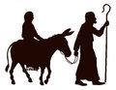  31__________________  No School | 25 Merry Christmas  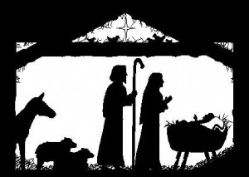 | 26 No School | 27 No school | 28 No School | 29
Lunches (includes drink) $3.75 each + $2.25 addt’l entrée / Milk Only$.55
*SUBWAY Selections: T = Turkey, H = Ham, I = Italian

