January 2019 St. John Neumann Regional School Lunches

Student______________________________Grade ____Print & return with payment Cash $_______Check # _____Check Amt.$_____
SUNDAY | MONDAY | TUESDAY | WEDNESDAY | THURSDAY | FRIDAY | SATURDAY
₃₀ | ₃₁ | _{Happy New Year} | 2 Spaghetti and Meatballs, Salad, Roll  _{Milk Only} | _{3 Chicken Pot Pies,}  _{Fruit Cup, Roll}  _{Milk Only} | _{4 Pizza, Dessert}  _{Milk Only} | ₅
₆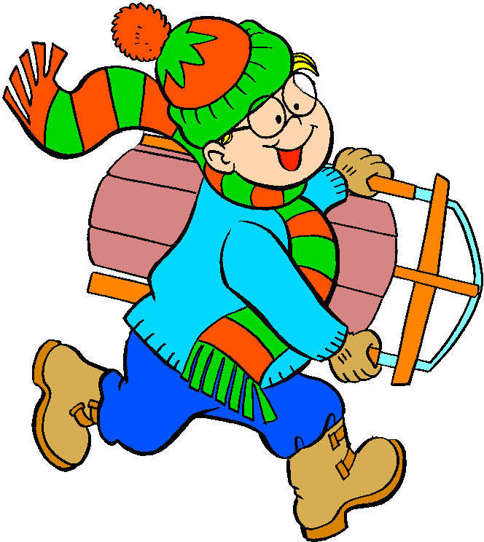 | _{7 Subway Mondays}  _{T H I}  _{Milk Only} | _{8 Burger with or with-}  _{out cheese, Tater}  _{Tots}  _{Milk Only} | _{9 Ham and Cheese}  _{Wrap, Chips}  _{Milk Only} | _{10 Blueberry}  _{Pancakes, Sausage}  _{Milk Only} | _{11 Pizza, Dessert}  _{Milk Only} | ₁₂
₁₃ | _{14 Subway Mondays}  _{T H I}  _{Milk Only} | _{15 Chicken and}  _{Waffles, Corn}  _{Milk Only} | _{16 Hot Dog,}  _{Beef-A-Roni}  _{Milk Only} | _{17 Smoked Sausage,}  _{Parsley Potatoes}  _{Milk Only} | _{18 Pizza, Dessert}  _{Milk Only} | ₁₉
₂₀ | _{21 No School}  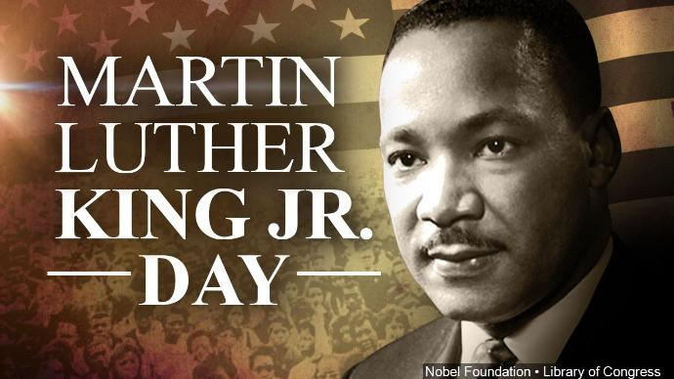 | _{22 Breaded Chicken}  _{Sandwich}  _{Carrots}  _{Milk Only} | _{23 Hot Turkey}  _{Sandwich, Mashed}  _{Potatoes}  _{Milk Only} | _{24 Grilled Cheese,}  _{Spaghettio”s}  _{Milk Only} | _{25 Pizza, Dessert}  _{Milk Only} | ₂₆
₂₇ | _{28 Subway Mondays}  _{T H I}  _{Milk Only} | _{29 Hamburger}  _{Bar-B-Q,}  _{Green Beans}  _{*Special Person’s Lunch PC}  _{Milk Only} | _{30 Breakfast Bowl}  _{with Bacon, Toast,}  _{Fruit}  _{Milk Only} | _{31 Salisbury Steak,}  _{Mashed Potatoes}  _{*Special Person’s Lunch SC}  _{Milk Only} | _{Feb. 1 Pizza, Dessert}  _{Milk Only} | ₂
Lunches (includes drink) $3.75 each + $2.25 addt’l entrée/.55 Milk Only
*SUBWAY Selections: T = Turkey, H = Ham, I = Italian

