February 2019 LUNCHES St. John Neumann Regional School

Student___________________________ Grade ___ Print & return with payment Cash $_______Check #_______Check Amt.$______
SUNDAY |  |  | MONDAY |  | TUESDAY |  | WEDNESDAY |  | THURSDAY | FRIDAY |  | SATURDAY
 |  |  |  |  |  |  |  |  |  | 1 |  | 2
3 |  |  | 4  Subway Mondays*  T H I  Milk Only |  | 5  Fish Sticks, French Fries  Milk Only |  | 6  Homemade Chili, Nachos with Cheese  Milk Only |  | 7  Chicken Nuggets, Broccoli  Milk Only | 8  Pizza  Dessert  Milk Only |  | 9
10 |  |  | 11  Subway Mondays*  T H I  Milk Only |  | 12  Mac & Cheese with Meatballs, Fresh Vegetables  Milk Only |  | 13  Hot Dog, Corn  Milk Only |  | 14 Happy Valentine’s  Day  Bacon, Egg, Cheese on English Muffin, Hash Browns  Milk Only | 15  Pizza  Dessert  Milk Only |  | 16
17 |  |  | 18 No School  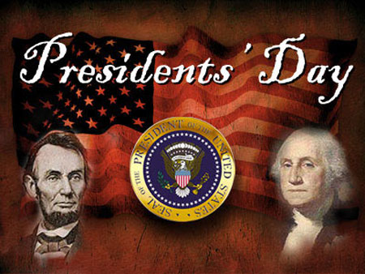 |  | 19  Hot Ham & Cheese on a Hamburger Roll, Pierogies  Milk Only |  | 20  Chicken Cordon Bleu Sandwich, Mixed Vegetables  Milk Only |  | 21  Beef Bar-B-Q, Oven Browns  Milk Only | 22  Pizza  Dessert  Milk Only |  | 23
 | 24 | 25  Subway Mondays*  T H I  Milk Only |  | 26  Turkey Mini Club, Macaroni Salad  Milk Only |  | 27  Chocolate Chip Waffles, Ham Loaf  Milk Only |  | 28  Ham and Green Bean Soup, Cheese Dog  Milk Only |  | March 1  Pizza  Dessert  Milk Only

SC = Peanut Free
Lunches (includes drink): $3.75 each +$2.25 additional entrée/55¢ Milk Only
*SUBWAY Selections: T = Turkey, H = Ham, I = Italian

