April 2019 LUNCHES St John Neumann Regional School

Student___________________________ Grade ___ Print & return with payment Cash $_______Check #_______Check Amt.$______
SUNDAY |  | MONDAY |  | TUESDAY |  | WEDNESDAY |  | THURSDAY | FRIDAY |  | SATURDAY
 |  | 1  Subway Mondays*  T H I  Milk Only |  | 2  Hamburger Macaroni,  Roll, Green Beans  Milk Only |  | 3  Ham and Cheese  Mini Club, Chips  Milk Only |  | 4  Chicken Sandwich,  Oven Browns  Milk Only | 5  Pizza  Dessert  Milk Only |  | 6
7 |  | 8  Subway Mondays*  T H I  Milk Only |  | 9  Fish Sticks, Mixed Vegetables  Milk Only |  | 10  Bacon Cheeseburger, Corn  Milk Only |  | 11  Blueberry Pancakes, Sausage  Milk Only | 12  Pizza  Dessert  Milk Only |  | 13
14  PALM SUNDAY |  | 15  Subway Mondays*  T H I  Milk Only |  | 16  Grilled Chicken with  Vegetable, Rice, Fruit  Milk Only |  | 17  Turkey wrap, Chips  Milk Only |  | 18  Homemade Vegetable Soup, Hot Dog  Milk Only | 19  GOOD FRIDAY |  | 20
21 Happy  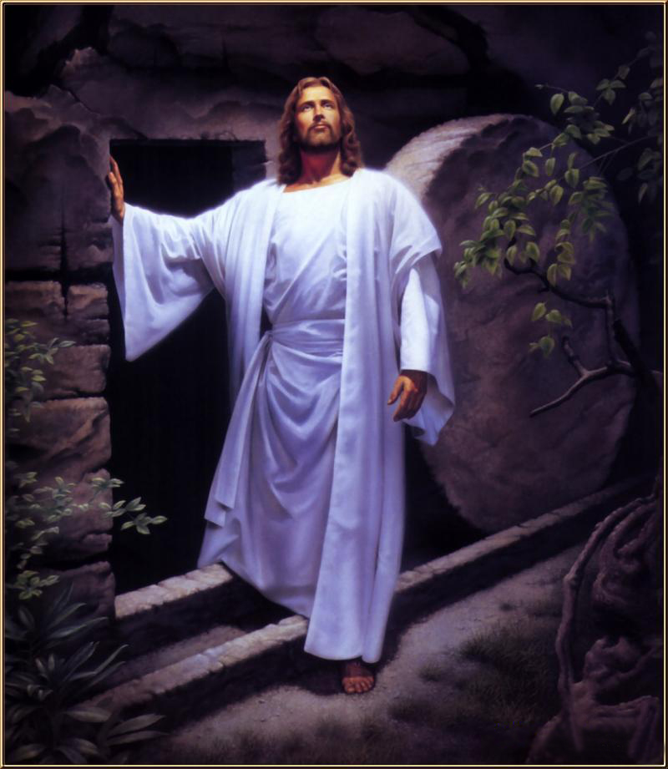  Easter |  | 22  Subway Mondays*  T H I  Milk Only |  | 23  Homemade Lasagna, Salad, Bread and Butter  Milk Only |  | 24  Popcorn Chicken Bowl, Roll, Dessert  Milk Only |  | 25  Waffles, Bacon  Milk Only | 26  Pizza  Dessert  Milk Only |  | 27
28 | 29  Subway Mondays*  T H I  Milk Only |  | 30  Mac & Cheese with Sliced Hot Dogs, Mixed Vegetables  Milk Only |  | MAY 1  Taco in Bag, Corn  Milk Only |  | 2  Smoked Sausage, Parsley Potatoes, Bread and Butter  Milk Only |  | 3  Pizza  Dessert  Milk Only | 4

SC = Peanut Free
Lunches (includes drink): $3.75 each +$2.25 additional entrée/55¢ Milk Only
*SUBWAY Selections: T = Turkey, H = Ham, I = Italian

