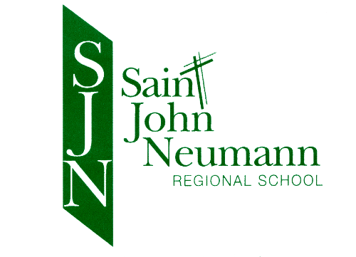DRESS CODE Updated 7/2/19

Goal: Students will always be clean, modest, and neatly
groomed students will not be distracted by the latest label or fashion.

Uniforms are purchased from Flynn & O’Hara Uniforms, Inc., Catasauqua Rd., Allentown, www.flynnohara.com

* SJNRS Dress Code prohibits clothing which is or exhibits vulgarity, profanity, double entendres, pictures, or slogans in school or at school sponsored functions.

BOYS

PANTS - Tan uniform slacks (November- March required)
Shorts or pants in warm weather (April-October)
SHOES -Soft soled and low heeled with backs (no flip-flops)
NOT PERMITTED - Boots or sneakers
SOCKS - Black or brown above the ankle
NOT PERMITTED - Athletic socks–except with gym uniform

TIES -Ties required with dress shirt
SHIRTS - Long or short sleeved white dress shirt, white banded or polo shirt or hunter green
polo with SJNRS logo
SWEATERS -White or dark green cardigan, pull-over or vest with SJNRS logo
NOT PERMITTED - Bulky or sloppy sweaters and logos other than SJNRS
T-SHIRTS - If a T-shirt is worn under the shirt, it must be solid white
JEWELRY - Only wristwatch, small cross, or medal (necklace)
NOT PERMITTED – Earrings or piercings
HAIR STYLE - Cut to a length which is above the collar; trimmed above eyes; must blend top layer in with back
NOT PERMITTED - Mushroom styles, razor cut or any other severe cuts (e.g. shaved sides, etc.); unnatural coloring/streaking

GIRLS-over
GIRLS

SHOES -Soft soled and low heeled with backs (no flip-flops)
NOT PERMITTED - Boots or sneakers (including black)
SOCKS - Dark green or white only
NOT PERMITTED-Athletic socks–except with gym uniform
TIGHTS - Green or white
BLOUSES/SHIRT – Long or short sleeved white blouse, turtleneck, banded or polo shirt, white or hunter green with SJNRS logo
JUMPERS - Grades K-3, with Peter Pan collar blouses or turtleneck
SKIRTS - Grades 4-8, length not more than 1” above knee; Grade 4 may wear the jumper
until it’s outgrown
SLACKS - Tan uniform slacks (November-March)
Shorts or pants in warm weather (April-October)
SKORT- All year, no shorter than 2” above the knee
SWEATERS -White or dark green cardigan, pull-over, or vest with SJNRS logo
NOT PERMITTED - Bulky or sloppy sweaters and logos other than SJNRS
JEWELRY - Wristwatch, small cross or medal (necklace), and no more than one set of small earrings during school time
NOT PERMITTED-Hoops or hanging earrings or bracelets, no more than one small ring on each hand, no nose piercings

HAIR STYLE - Hair must be styled so as not to be hanging in the eyes
NOT PERMITTED - Severe hair styles; unnatural coloring/streaking
HEADBANDS - Small, inconspicuous headbands or bows
MAKEUP - NOT PERMITTED (makeup of any kind)

Casual Day
SJNRS prohibits clothing which is or exhibits vulgarity, profanity, double entendres, pictures, or slogans. No tight pants permitted.

Gym Day Dress Code
All students from K-8 are required to wear the official gym uniforms which includes a SJNRS gray (‘ACHIEVER’) T-shirt or a Walk-A-Thon shirt of the current or previous year only, green shorts or gray sweat pants (no leggings), and gray sweat shirt.
Regulation sneakers are also to be worn.

All of the above (with the exception of the Walk –A-Thon T-shirt) is to be purchased from
Flynn & O’Hara Uniforms, Inc., www.flynnohara.com

