St. John Neumann Regional School SEPTEMBER 2019 LUNCHES

Student___________________________________ Grade ______ Print & return with payment $___________ Cash/Check ___________

SUNDAY | MONDAY | TUESDAY | WEDNESDAY | THURSDAY | FRIDAY | SATURDAY
 | AUG 26  Early Lunch/early dismissal  Packed Lunch | 27  & Drink only this week | 28 | 29 | 30  NO SCHOOL | 31
1 | 2  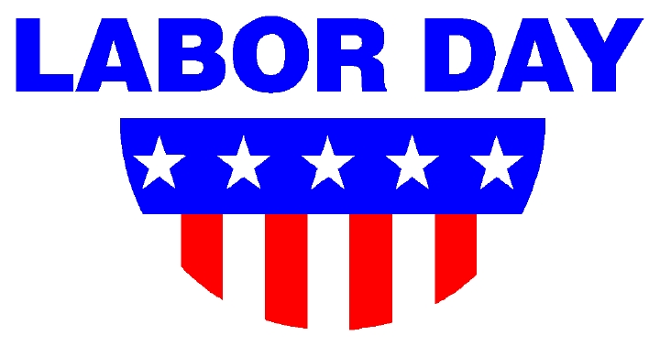 | 3  Grilled Cheese  Beefaroni  Milk Only | 4  Blueberry Pancakes  Sausage  Milk Only | 5  Spaghetti & Meatballs  Salad  Roll  Milk Only | 6  Pizza  Dessert  Milk Only | 7
8 | 9  Subway Mondays*  T H I  Milk Only | 10  Beef BBQ  Tater Tots  Milk Only | 11  Breakfast Bowl  w/Bacon  Fruit  Milk Only | 12  Marinated Chicken Breast Sandwich  Corn  Milk Only | 13  Pizza  Dessert  Milk Only | 14
15 | 16  Subway Mondays*  T H I  Milk Only | 17  Turkey Wrap w/Chips  Milk Only | 18  Egg/Cheese/ Sausage Croissant  Hash Browns  Milk Only  NO LUNCH | 19  Homemade Chicken Noodle Soup  Hot Dog  Milk Only | 20  Pizza  Dessert  Milk Only | 21
22 | 23  Subway Mondays*  T H I  Milk Only | 24  Chicken & Broccoli  Rice Pilaf  Carrot Sticks  Milk Only | 25  Chocolate Chip Waffles  Ham  Milk Only | 26  Smoked Sausage  Parsley Potatoes  Bread/Butter  Milk Only | 27  Pizza  Dessert  Milk Only | 28
Lunches (includes drink): $3.75 each +$2.25 additional entrée/.55 Milk Only
*SUBWAY Selections: T = Turkey, H = Ham, I = Italian

