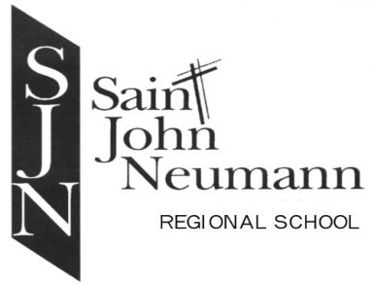
Palmerton Campus: 259 Lafayette Avenue, Palmerton, PA 18071 (610) 826-2354
Slatington Campus: 641 West Washington Street, Slatington, PA 18080 (610) 767-2935
www.sjnrschool.org

+
August 18, 2020
ADDENDUM to SJNRS HEALTH & SAFETY PLAN:
Last week, the American Academy of Pediatrics (AAP) released an update to their guidance strongly recommending children age two and older should wear face coverings at all times to help mitigate the spread of the COVID-19 virus. Prior guidance we released in collaboration with the Pennsylvania Department of Health (DOH) stated students in schools could remove their face coverings as long as six feet of social distancing could be maintained. Given this recent change from the AAP, and consistent with the Secretary of Health’s Face Covering Order issued on July 1, 2020, DOH is requiring students wear face coverings at all times while in school, even when six feet of social distancing can be achieved. There are limited exceptions.
Schools may allow students to remove face coverings when students are:
- Eating or drinking when spaced at least 6 feet apart; or
- When wearing a face covering creates an unsafe condition in which to operate equipment or execute a task; or
- At least 6 feet apart during “face-covering breaks” to last no longer than 10 minutes.

Visit our Answers to FAQs on Face Coverings/Masks webpage for more information.

The link on the Pennsylvania Department of Education website with this new information is:
https://www.education.pa.gov/Schools/safeschools/emergencyplanning/COVID-19/SchoolReopeningGuidance/ReopeningPreKto12/PublicHealthGuidance/Pages/default.aspx
Thank you,
Mrs. Mary Comensky

